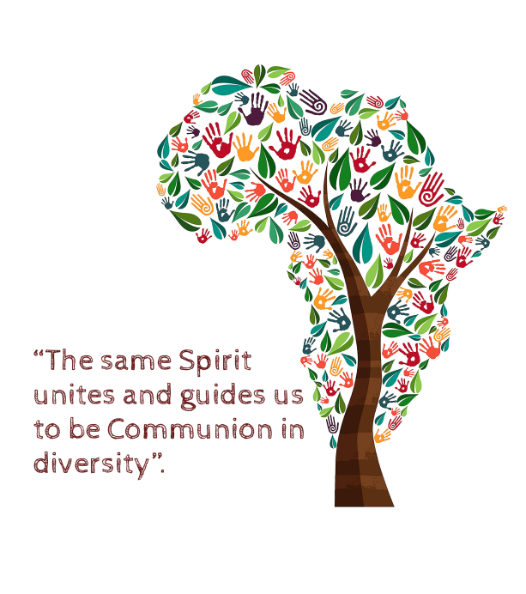
PRE-CHAPTER PRAYER
God of Goodness and Mercy, we thank You for the gift of our charismatic family in African lands.
You have believed in us and given us gratuitously your being and life through the charism of Universal Charity. We believe it is a gift from You and count on You.
Breathe on us your spirit of renewal, of fidelity and mark us with the seal of creative Hospitality.
Centred in Christ, we form fraternal and joyful communities, where life is given and received as a testimony of the presence of Christ and Christian charity.
Conscious of our weaknesses, we place in your hands our being and doing in the living and updating of this inheritance.
We know that You walk with us. Your presence gives us security and places us on the way towards the others.
With Mary, our Lady of Salz, our Mother and Patroness, we commit ourselves to advance in this path of love.
Fill us with your Mercy to make us be reborn to the life of fraternal communion that You dream for us.
We ask you, Father of Love, through Jesus Christ your Son, our Lord and God who lives and reigns with You in the unity of the Holy Spirit forever and ever. Amen.

